# Vermont WIC 2009 Special Project Grant: Supporting Long-Term Breastfeeding with the New WIC Food Packages

# Social Marketing Materials

Below are guidelines and recommendations for using materials from the *You Can Do It, WIC Can Help* Breastfeeding Study. Best practice tip: When sharing any of these materials with local partners and HCP's, schedule time to meet face-to-face with staff for a mini-in-service, rather than just dropping them off or mailing them.

\*Core participant resource in use prior to the study

|  |  |
| --- | --- |
|  | \* WIC Food Packages for Moms and Infants  Promotes breastfeeding, illustrates food packages available to moms and infants based on the amount of breastfeeding: exclusively breastfeeding, mixed feeding and formula feeding. Recommended use: All prenatal and breastfeeding moms. (Adapted with permission from Texas WIC) |

|  |  |
| --- | --- |
| \\Nessie\cph\Common\WIC\Mother-Baby_Breastfeeding_Study\Presentations\Small_images_of_materials\comic_cover.jpg | Main Street Moms: I Got Milk comic/graphic novel Presents stories of 4 breastfeeding mothers in graphic novel format. Emphasizes the importance of social support for breastfeeding success. EncouragesMoms to share breastfeeding goals and plans with family and friends. Recommended use: Offer as early as possible in pregnancy. Especially suitable for first time moms, any mom who has never breastfed, or who has had a negative breastfeeding experience in the past. |

## 

|  |  |
| --- | --- |
|  | My Breastfeeding Checklist:  for Pregnancy through the First Few Weeks  Provides specific information and action steps in a checklist format to help mothers prepare for a successful breastfeeding experience prenatally. Lists local and national resources. Recommended use: review with prenatal participants at their initial WIC certification. Together with mom, start completing the various sections and write in your contact information in the space provided. Encourage her to bring the checklist with her to all of her prenatal appointments and use as a communication tool with her health care provider. Mom's interim prenatal WIC contact is a great time to help her complete Section 3, The First Weeks at Home. |
|  | My Breastfeeding Checklist:  for the First Few Months and Beyond  Provides specific information and action steps in a checklist format to help mothers prepare for a successful breastfeeding experience postnatally. Lists local and national resources. Recommended use: Review the signs that breastfeeding is going well, and when/where to seek help at a late prenatal interim WIC contact. At her postpartum WIC appointment, use to encourage Mom to communicate her breastfeeding goals and plans to her employer and child care provider. |

|  |  |
| --- | --- |
|  | \*Breastfeeding: Keep it Simple.  Amy Spangler, MN, RN, IBCLC. Answers common questions about breastfeeding in a conversational yet detailed book. Contains helpful illustrations and on-line resources. Recommended use: Offer to prenatal women considering breastfeeding and breastfeeding moms. Use to tailor education to participants’ specific questions and interests by directing them to the appropriate pages. |

|  |  |
| --- | --- |
| ***\\Nessie\cph\Common\WIC\Mother-Baby_Breastfeeding_Study\Presentations\Small_images_of_materials\dvd_sleeve_art.jpg*** | What Breastfed Babies Do DVDwith Amy Spangler, RN, MN, IBCLC  Through a series of short videos, Amy Spangler shares tips on what to expect in the first 10 days after birth. The segments are < 5 minutes each, and designed to be viewed independently from each other. This format provides an ideal way for busy moms to get a quick "bite" of concise information. The DVD could be given at an interim prenatal contact, and 1 or 2 segments shown at a prenatal breastfeeding class. |

|  |  |
| --- | --- |
| \\Nessie\cph\Common\WIC\Mother-Baby_Breastfeeding_Study\Presentations\Small_images_of_materials\hospital_experience.jpg | \*The Hospital Experience:  What to expect and how to make it memorable  Helps mom prepare for early breastfeeding success. Outline hospital practices the support breastfeeding. Includes a hospital packing list and a tear-out infant feeding plan. Recommended use: Prenatal women.  (Adapted with permission from Texas WIC) |

## 

|  |  |
| --- | --- |
|  | Buttons  Wear in the hospital; identifies mom and her support people as breastfeeding. Recommended use: offer at third trimester group breastfeeding class |

|  |  |
| --- | --- |
| \\Nessie\cph\Common\WIC\Mother-Baby_Breastfeeding_Study\Presentations\Small_images_of_materials\magazine_cover.jpg | Born and Raised the Vermont Way magazine  Provides positive social marketing messages around breastfeeding and presents nursing as the social norm. Six Vermont WIC families share their breastfeeding experiences through pictures and personal stories. Interviews with an IBCLC and a WIC Breastfeeding Peer Counselor help moms learn what to expect and where to get help. Recommended use: Intended for use in clinic waiting areas. |

|  |  |
| --- | --- |
|  | Caring Means… Door Hangers  Helps new moms and dads to set limits for visitors after birth, and offers suggestions for family and friends that will help make breastfeeding a success. Recommended use: Distribute at group breastfeeding class. |

|  |  |
| --- | --- |
|  | Breastfeeding. Natural, Biological, Instinctual. Challenging.  Detail Brochure for Providers: Modeled after formula rep materials, this brochure states the problem (most moms want to breastfeed but fail to meet their goals) and offers solutions. Emphasizes what WIC has to offer and the benefits of partnering with WIC to support breastfeeding. Intended to be used as part of a presentation at a provider staff meeting. An accompanying power-point, facilitator guide, local data sheets and other resources for making an effective presentation are available. |

## Clinic Poster Series: Knowledge, Support, Confidence, and Success

(18 x 24 format) Conveys key messages to promote breastfeeding success and WIC’s role in supporting breastfeeding. Recommended use: Display in clinic waiting areas and certification rooms.

Knowledge; Support; Confidence; Success **(**pink series **-** intended for use in WIC clinic spaces.)

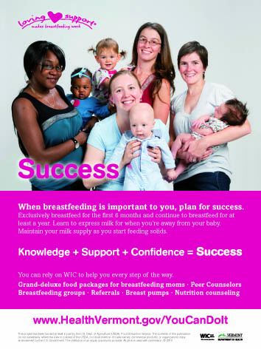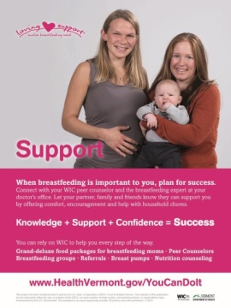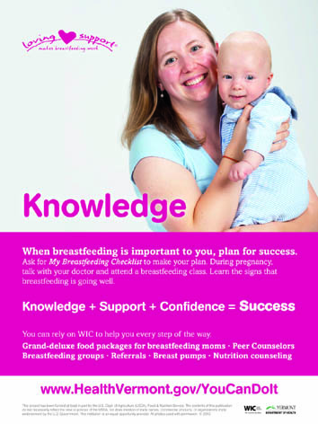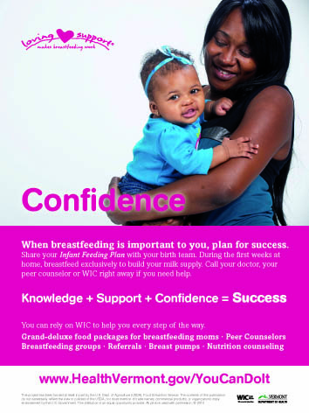

Plan for Success(OB/FP) (Peds/FP) (blue series - intended for prenatal health care providers and to local providers who care for infants and children)

